Introduction

1.1 Overview :

Retail Management deals with selling of goods and services to consumers. It involves a direct interaction with the customer and coordinating business activities from designing of a product to its delivery and post-delivery service. Those who are specialists in retail management are generally known as Retail Managers. A Retail Manager is expected to address consumers’ problems, monitor retail orders, handle merchandising, manage HR and also supervise the stocks/inventory and supply chain management.

1.2 Purpose:

There is a huge number of retail management systems available on the market, so one does not know where to look first when the question of choosing an automated assistant comes up. Like with anything else, study the reviews with a system’s pros and cons highlighted. For obvious reasons, we recommend giving priority to non-sponsored tops and listings of retail management systems software.Some websites that give lists of most used or more highly rated software have customizable filters for you to specify the set of desired functions. Additionally, some of them, such as GetApp, allow adding the selected items to comparison so that you can see their functionality side by side.

2.Problem definition and design thinking:

2.1 Empathy Map :

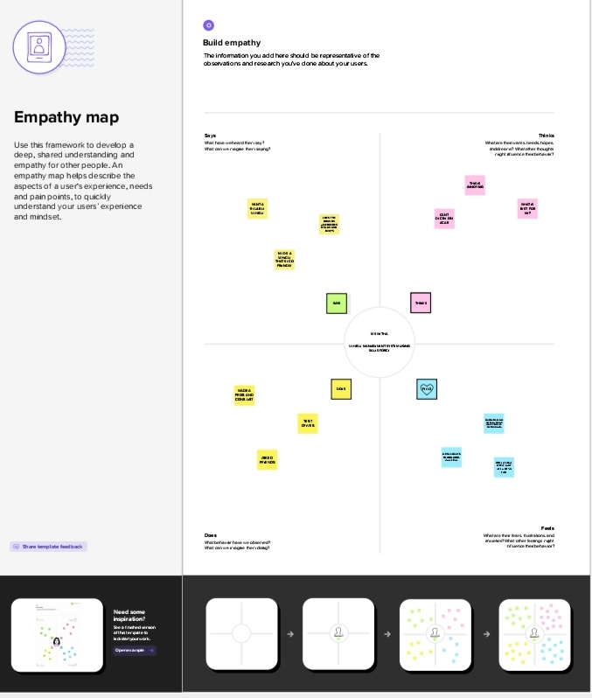

2.2 Ideation & Brainstorming Map :

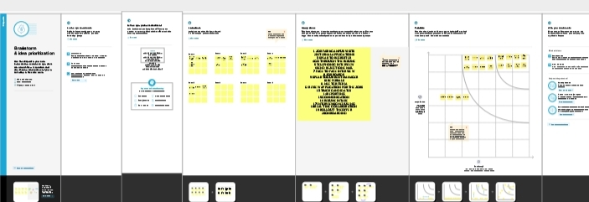

3.Result:

3.1Data Model

|  |  |
| --- | --- |
| Object Name | Field in the object |
| Obj 1 | |  |  | | --- | --- | | Field Label | Data Type | | Created by | Lookup | |
| Obj 2 | |  |  | | --- | --- | | Field Label | Data Type | | Name | Text | |

3.2 Activity and Screenshot:

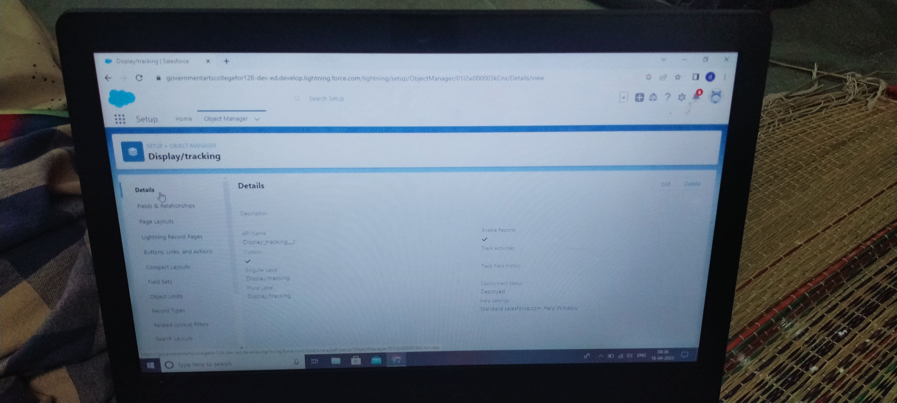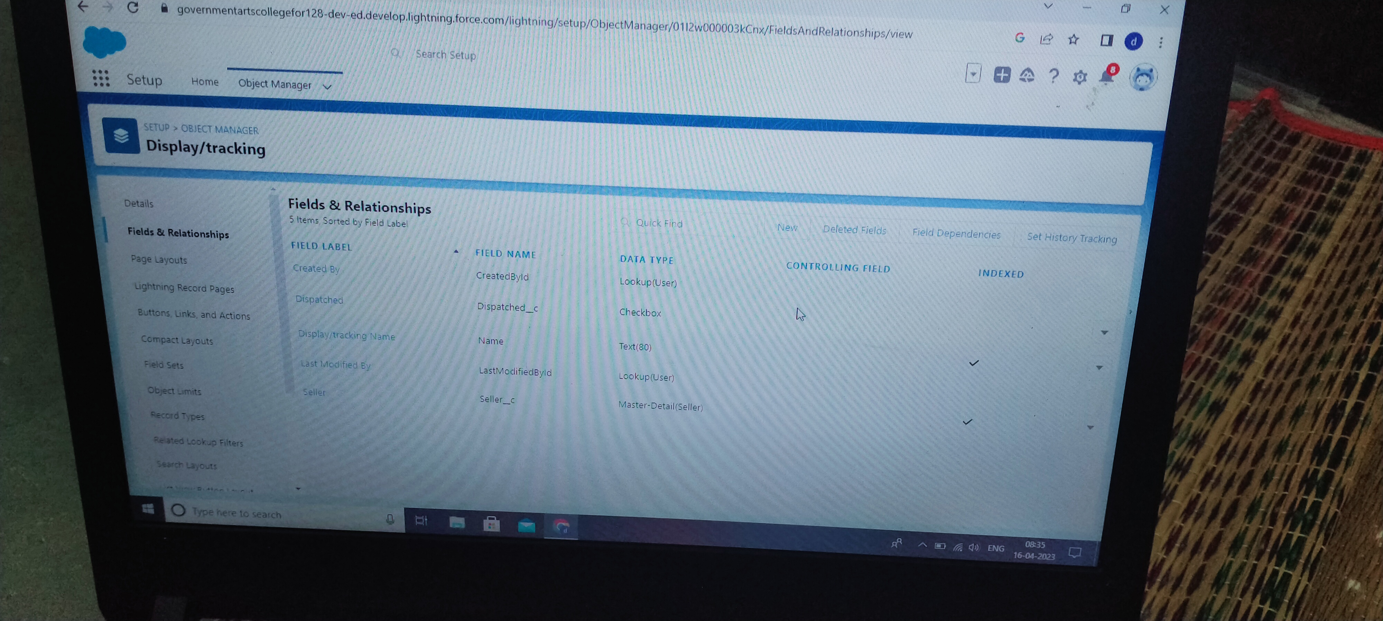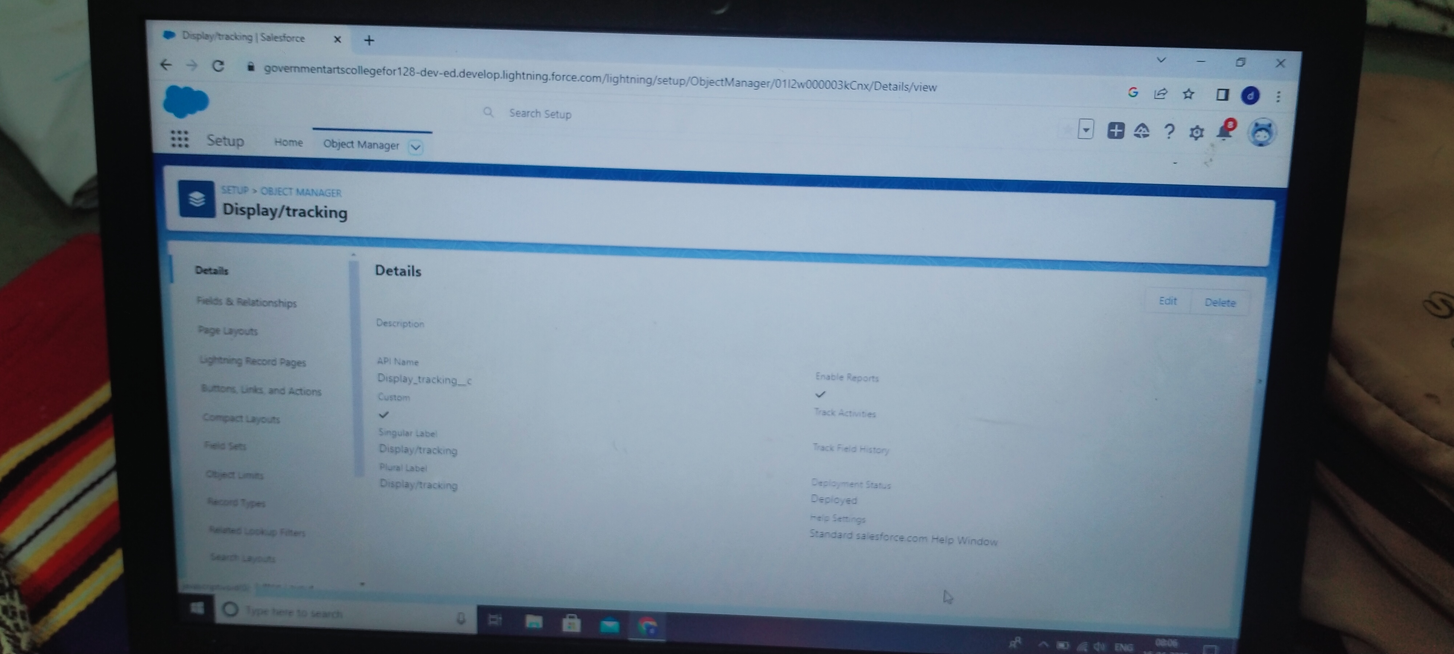

4. Trailhead Profile Public URL:

Team leader -https://trailblazer.me/id/ddharni

Team Member 1-https://trailblazer.me/id/arthi25

Team Member 2-https://trailblazer.me/id/kdhanalakshmi5

Team Member 3-https://trailblazer.me/id/deepa1780

5 Advantages and Disadvantage :

The main advantages of retailers can be described as follows

1. Less Capital Requirement

It does not require huge investment to start retail business. Retailers buy goods from wholesalers in small quantity and sell to ultimate customers. It does not need large space to store goods. So, retailing can be commenced with little investment.

2. More Profit Margin

There is fixed margin of profit for wholesalers. Generally they earn 3% to 8% profit on sale. But there is no fixed margin for retailers, shopkeepers may fix profit margin up to 20% in some cases.

3. Credit Facility

Another benefit of retailers is that they get credit facility from wholesalers or dealers. But they sell products on cash which helps to maintain adequate liquidity in the business.

4. Better Customer Relation

Retailing is directly linked with the customers. Retailers can understand the interests, preferences and buying behavior of customers. It helps to build better customer relation and loyalty.

Disadvantage :

The main disadvantages of retailers can be described as follows:

1. High Marketing Cost

Retailers should make investment in decoration of shop and display of goods to attract more customers. So, requires more marketing or advertising cost than wholesalers.

Also Read:

Advantages And Disadvantages Of Wholesalers

Difference Between Wholesalers And Retailers

2. Selling Skill Required

It requires good selling skill to attract customers. Retailers should possess the art of good communication and convincing power to influence consumers.

3. Very High Competition

Another disadvantage of retailing is that there is tough competition in the market because several retailers sell similar types of products. So, it is difficult to remain in the competitive environment.

4. No Economies Of Buying

Retailers buy small volume of products from wholesalers. So, they miss the opportunity to enjoy he benefit of economies of buying.

6.Application:

IT helps to store customer data, which the retailer can then use to reach out to customers. Through email with personalized offers or with mail offers. And when at the check-out process, retailers can search up the customer's information to make their experience efficient and quick.Management Information Systems (MIS) have been developed for each of those areas. Example applications include finances, marketing, manufacturing and human resources. Each type of MIS is designed to meet the needs of management in those departments or units.The application is a cloud-based data management software that allows you to have handy analytical tools needed to store data on the Microsoft Azure cloud. The application allows you to have multiple warehouse/ database styles with many different data tools to manage every ounce of data you have

7.Conclusion

In this course we have explored the meaning of the terms retailing, marketing and marketing communications. We have also considered the importance of the marketing mix and identified the different communication tools that a retailer might use to interact and communicate with their target customers. You have been introduced to a few theoretical concepts and ideas, which have been illustrated using real world examples and cases in retailing.You have been introduced to some of the key areas of marketing communications – the message, the media and the communication tools. You have considered the basics of the communication model that underpins the development of marketing communication messages. You have also explored what it takes to develop a communication message, how to use communications to build a brand and the characteristics of the different media that might carry marketing communications. In addition, you have identified a range of communication tools which make up the marketing communication mix.The course has also aimed to introduce the importance of marketing and communication from a retail perspective.

8.future scopes:

The future of retail will feature a high level of online penetration. The best suppliers will establish direct-to-consumer relationships, where retailers will no longer serve as the gatekeeper to the customer.Last year, on July 20, the Mumbai bench of the NCLT had admitted Bank of India's petition to start the corporate insolvency resolution process against Future Retail and appointed Vijay Kumar Iyer as the resolution professional.As per EY India India's retail market is estimated to reach $1.5 trillion by 2030, from $0.8 trillion in 2020, indicating that there is a massive opportunity for growth. While globally and in India, the retail sector has taken a hit due to Covid-19.